**Aim**

To implement both Linear Search and Binary Search in a single program with a menu-driven approach.

**Algorithm**

1. Start
2. Input size of array and its elements
3. Display menu:
   * 1. Linear Search
   * 2. Binary Search
4. Take choice from user
   * If choice = 1 → Perform Linear Search
   * If choice = 2 → Perform Binary Search (array must be sorted)
5. Display result (found/not found with position)
6. Stop

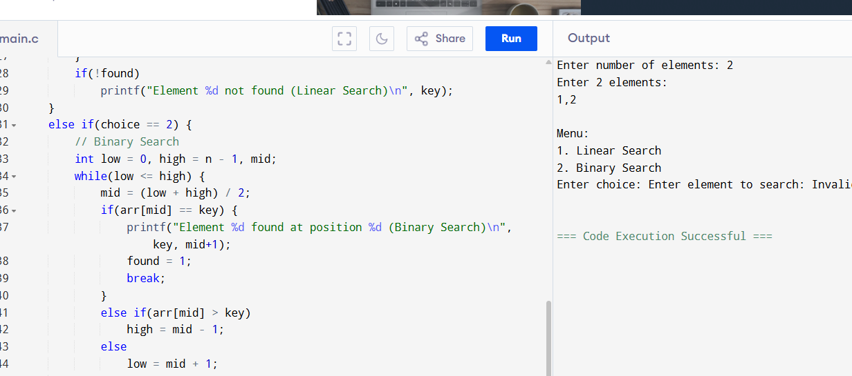

**Output**

Element 20 found at position 4 (Binary Search)